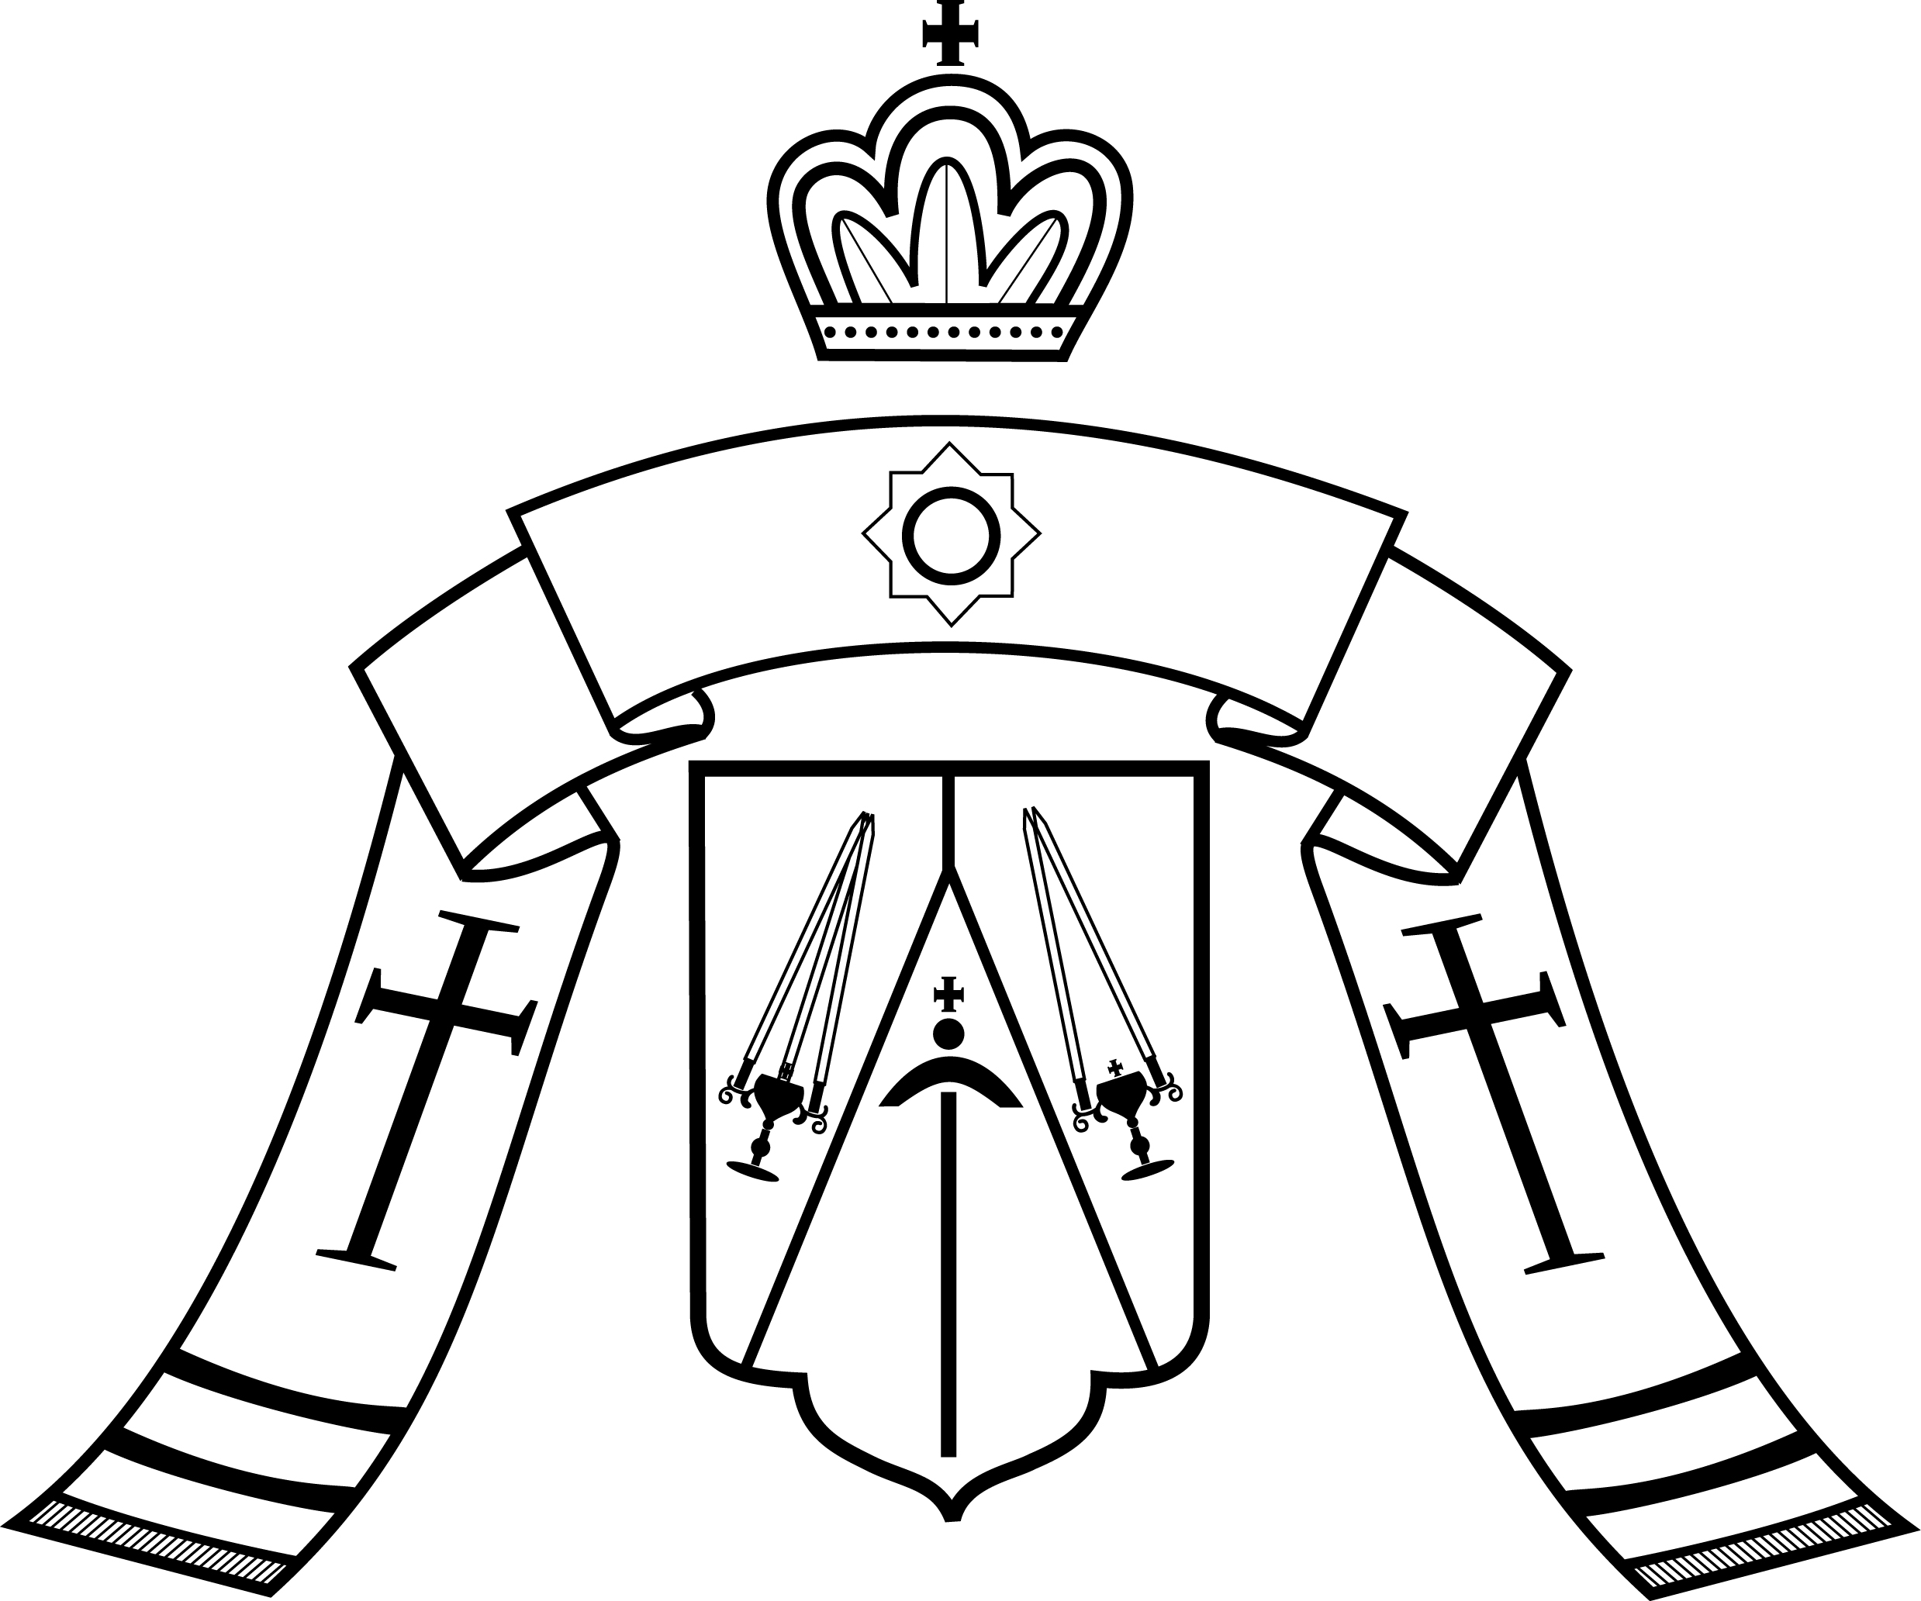

Paschal Epistle of

KYRILL

Archbishop of San Francisco and Western America

Reverend Fathers, Venerable Monastics, and Pious Faithful of the Western American Diocese:

Christ is Risen! Truly, He is risen!

Once more we revel in the joy of the Feast of Feasts, as the empty tomb proclaims new life to the whole world. Our faith, though at times frail and tender, has brought us nevertheless to these bright days; and whether like the Holy Apostles we had fled Christ’s side or like the holy Myrrhbearing Women we had remained faithfully at His feet through these long lenten days, our Lord has brought us to His Resurrection together. We are united with all creation in venerating this incomprehensible triumph of life over death, of love over hatred, of divinity over apathy. We are one family, one body, and today our Head has conquered everything that could divide us. He has seen our weakness and our frailty, and He has made us whole.

Let there be no limit to the pious rejoicing that stirs now in our hearts as the Lord lifts us by the hand out of hades, through the shattered gates of hell, towards His Kingdom of eternal life. May this gift transform us into new examples of piety, love, humility and kindness, and may we know within our hearts the true meaning of the words that change the universe: Christ is Risen! Truly, He is Risen!

Bestowing upon you my archpastoral blessing, and wishing you the joy of the Feast,

Christ is risen! Truly, He is risen!

Pascha 2015

