with the blessing of his eminence archbishop kyrill

holy royal martyrs of russia church in reno, nevada brings you:

russian orthodox cruise: 7 nights to alaska on Holland America roundtrip from seattle – July 28-august 4, 2019

rates:
- from $ 1,829 per person - inside cabin
- from $ 2,129 per person - ocean view cabin
- from $ 2,569 per person - balcony cabin
- from $ 3,069 per person - balcony suite

(based upon double occupancy) ** reserve with $350 deposit by 12/3/18

rates include:

- one night stay in seattle hotel prior to cruise
- visit saint nicholas church in seattle, wa
- transportation from seattle hotel to cruise port
- 7 night cruise aboard the ms oosterdam- accommodations and meals
- $50 per cabin shipboard credit
- clergy escort- onboard prayer services
- visit saint michaels cathedral- sitka, alaska
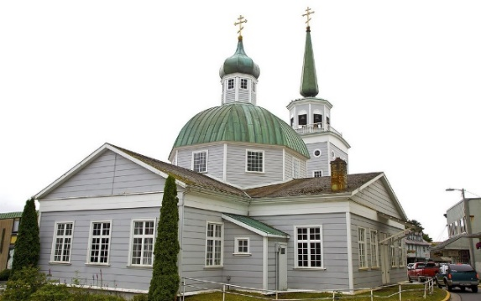
- visit saint nicholas church - juneau, alaska

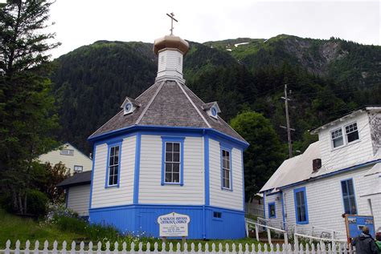
Saint Michael’s Cathedral - Sitka
Saint Nicholas Church - Juneau
Itinerary
Day | Port | Date | Arrive | Depart
1 | Seattle | Sunday, 07/28/2019 | -- | 4:00 pm
1 | At Sea | Sunday, 07/28/2019 | -- | --
2 | At Sea | Monday, 07/29/2019 | -- | --
3 | Scenic Cruising Stephens Passage | Tuesday, 07/30/2019 | -- | --
3 | Juneau | Tuesday, 07/30/2019 | 1:00 pm | 9:00 pm
4 | At Sea | Wednesday, 07/31/2019 | 2:00 pm | 6:00 pm
5 | Sitka | Thursday, 08/01/2019 | 8:00 am | 4:00 pm
6 | Ketchikan | Friday, 08/02/2019 | 7:00 am | 1:00 pm
7 | Victoria | Saturday, 08/03/2019 | 6:00 pm | 11:30 pm
8 | Seattle | Sunday, 08/04/2019 | 7:00 am | --

Visit our group page at www.mscruiseplanners.com to register, or complete and return reservation form. For questions, contact:

Mary Gousev- (775) 332-0580 or 888-672-7896.

E-mail: mary.gousev@cruiseplanners.com

Father Deacon Alexander Gousev- (775) 287-0982.
E-mail: deacongousev@hotmail.com

